OSSP (Operating Systems And Systems Programming) - 25CS2104E
1(a). Develop a C program that demonstrates how a Linux operating system executes a command entered by a user that 1. Accept a Linux command as input. 2. Create a child process using fork(). 3. Execute the command in the child process using an appropriate exec() system call. 4. Allow the parent process to wait for the child using wait (). 5. Display the Process ID (PID) of both parent and child processes.
Program:
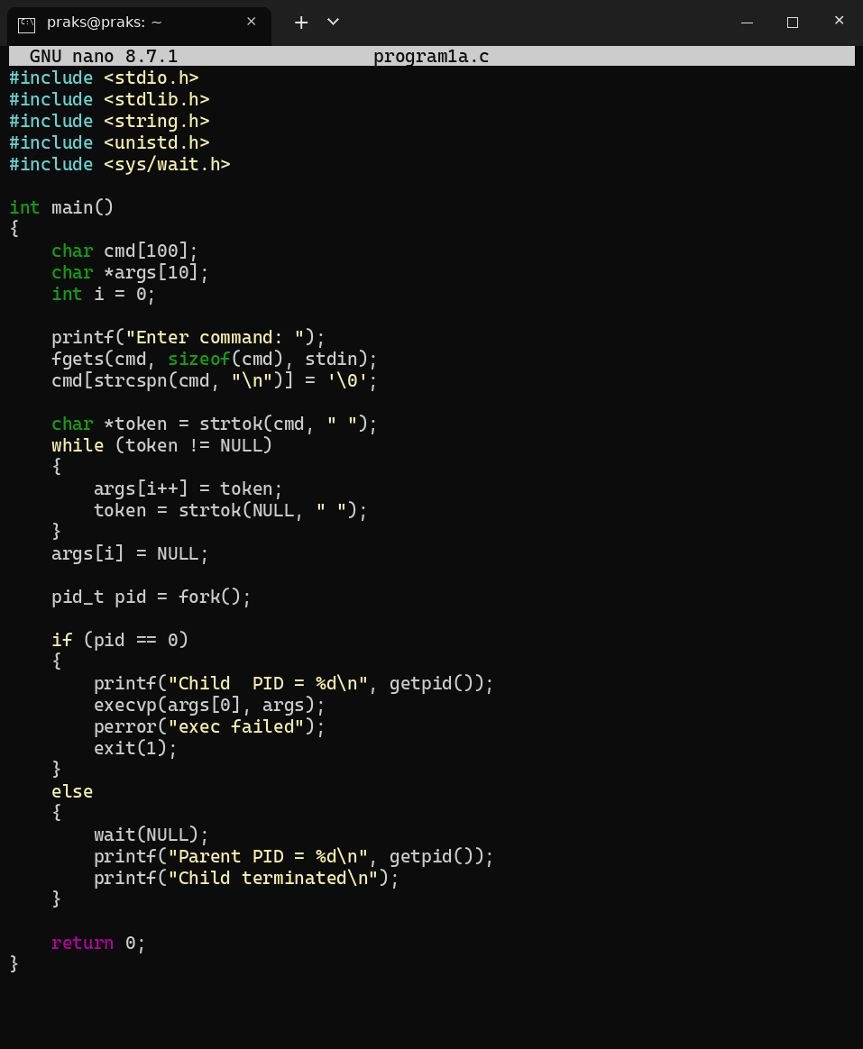
Output:
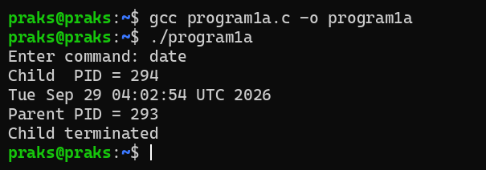
1(b). Using Linux terminal commands (uname, lscpu, lsblk, ps, top), investigate the relationship between hardware resources and operating system services. Prepare a report explaining how the OS abstracts CPU, memory, storage, and I/O devices.
Commands and Output:
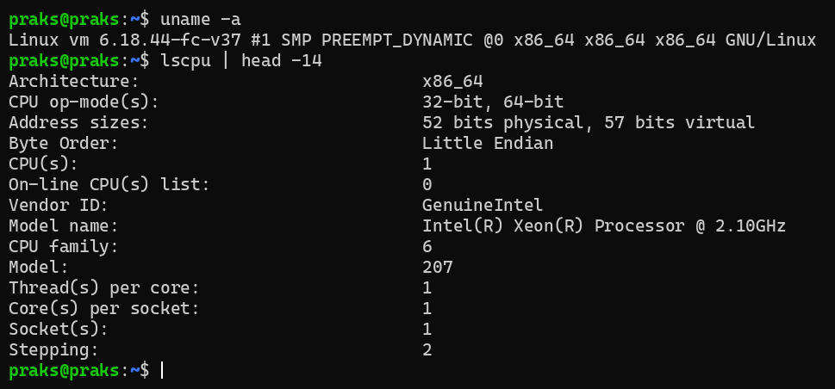
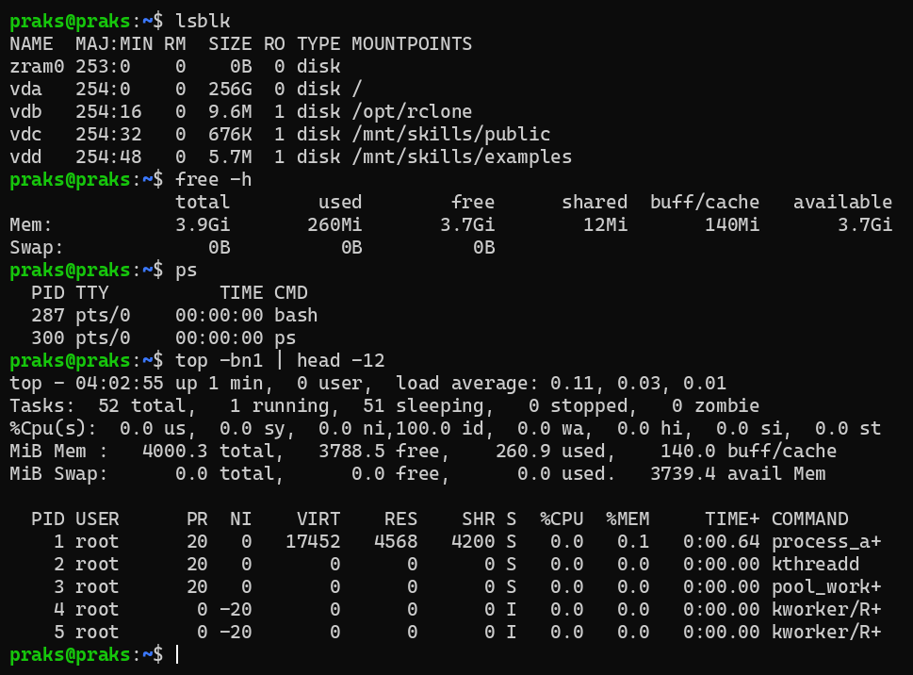
Explanation: CPU: lscpu shows the physical CPU, but the OS scheduler shares it between all processes (ps, top), so every process behaves as if it has its own CPU. Memory: free shows the physical RAM, which the OS turns into a private virtual address space for each process. Storage: lsblk shows the disks, which the OS presents as files and directories through the file system. I/O devices: keyboard, terminal and disks are used through device files and system calls like read() and write(), so programs never touch the hardware directly. uname shows the kernel that provides all these services.
2(a). Develop a C program that uses the system calls open(), read(), write(), and close() to copy the contents of one file to another. Explain how control transitions between user space and kernel space during execution.
Program:
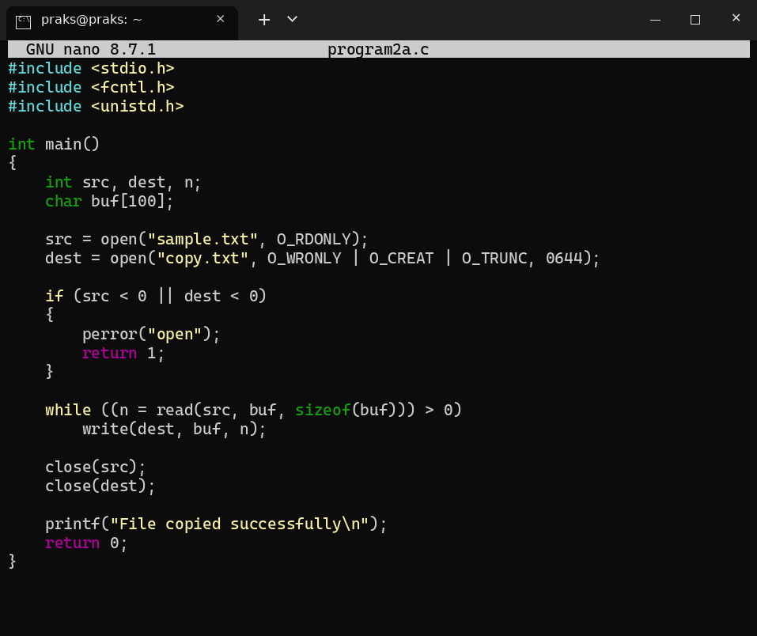
Output:
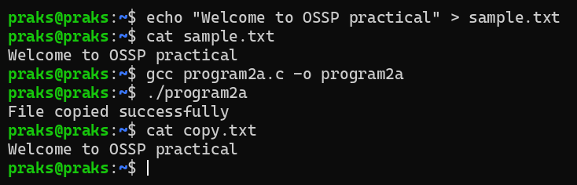
Explanation: Each call to open(), read(), write() or close() executes a trap instruction. The CPU switches from user mode to kernel mode, the kernel performs the work (file system and disk access), stores the result and returns to user mode, and the program continues. So every system call is one user space to kernel space and back transition.
2(b). Use the strace utility to trace all system calls generated by the command cat sample.txt. Analyze the sequence of system calls and identify the kernel services involved.
Commands and Output:
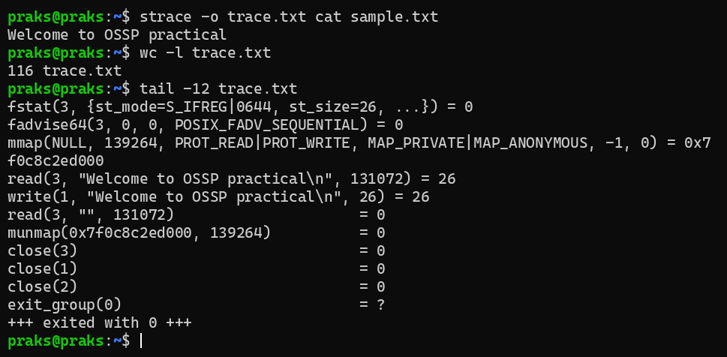
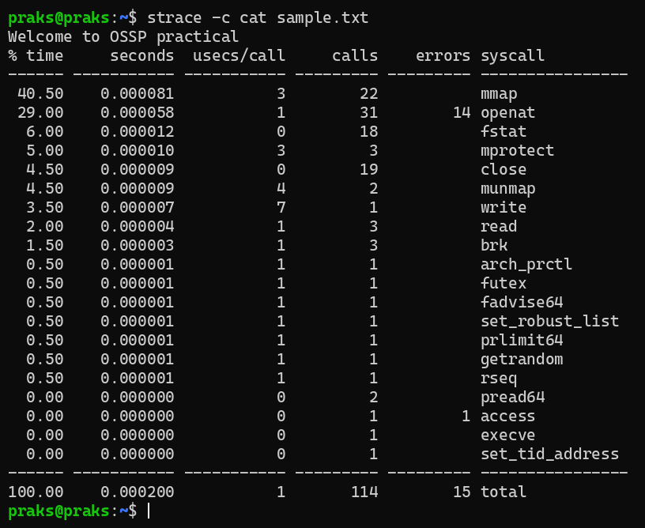
Explanation: Sequence: execve (load program), brk and mmap (memory setup), openat, read, close (load libc), then openat("sample.txt"), fstat, read (get data from file), write(1, ...) (print on terminal), and finally close and exit_group (end process). Kernel services involved: process management (execve, exit_group), memory management (brk, mmap, munmap), file system (openat, fstat, read, close) and I/O (write to terminal).
3(a). Develop a C program using fork() that creates a parent and child process. Display the Process ID (PID), Parent Process ID (PPID), and process states at different stages of execution.
Program:
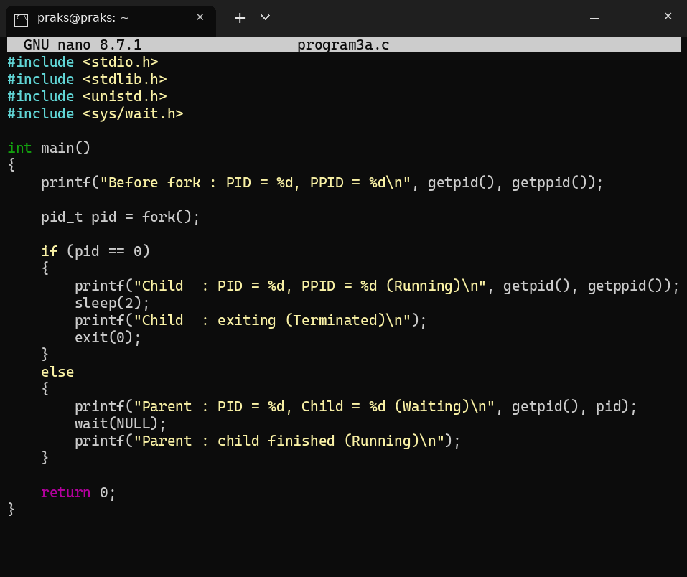
Output:
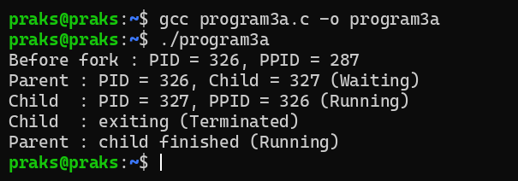
3(b). Design an experiment to observe process state transitions (Ready, Running, Waiting, Terminated) using Linux monitoring tools such as ps, top, and /proc. Document the observations.
Commands and Output:
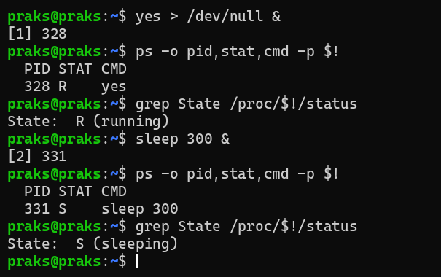
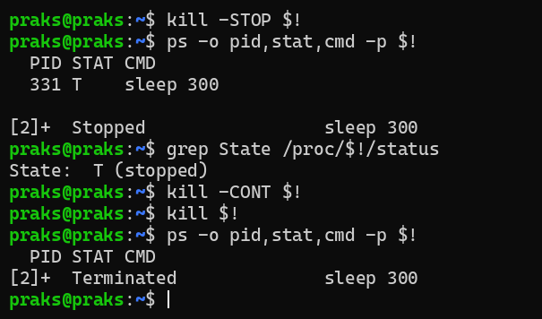
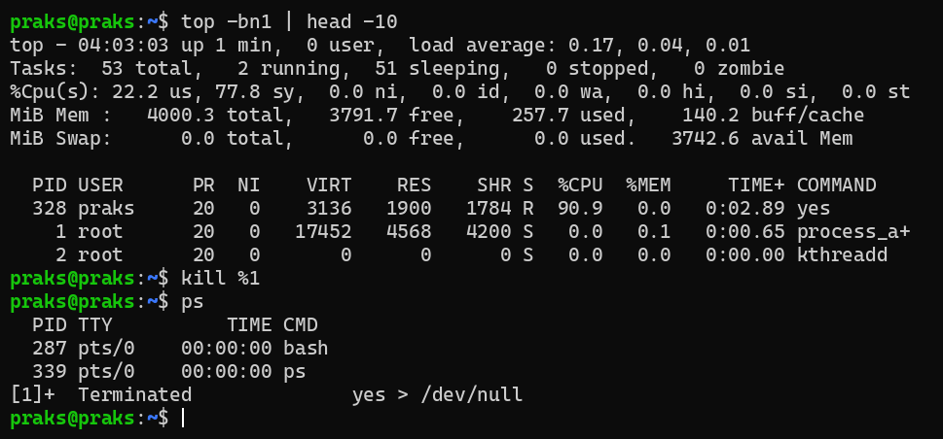
Explanation: yes never waits, so it is always Running/Ready (R) and top shows about 100% CPU. sleep 300 waits for a timer, so it is Waiting (S, sleeping). After kill -STOP the state becomes T (stopped), and after kill the process is Terminated and no longer appears in ps. Linux uses the same state R for both Ready and Running.
4(a). Write a C program where a parent process creates multiple child processes and synchronizes their completion using wait() and waitpid(). Compare the behavior of both functions.
Program:
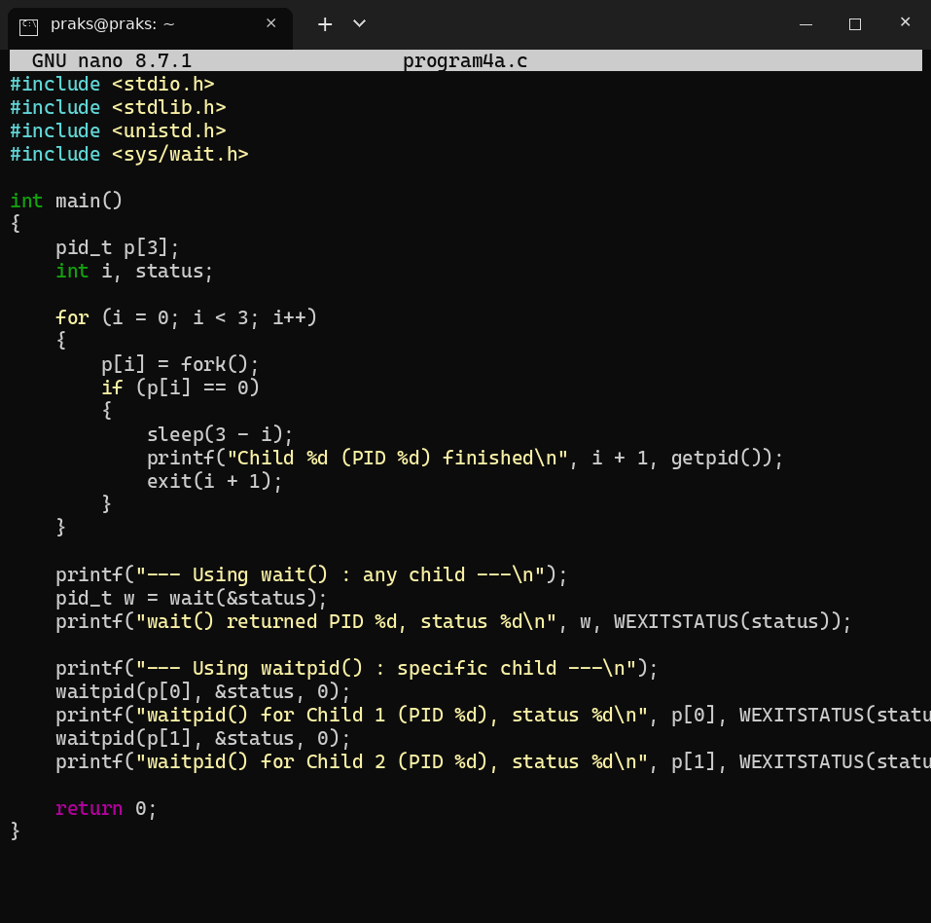
Output:
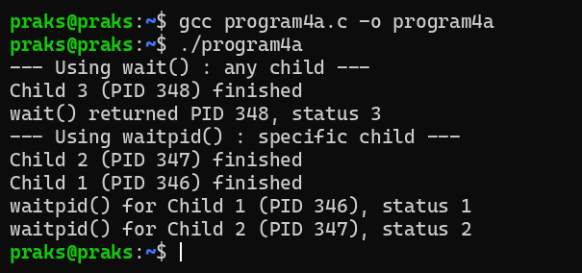
Explanation: wait() returns for whichever child finishes first (Child 3 here), so the order cannot be chosen. waitpid() waits for one particular child, so Child 1 and Child 2 were collected in the order we wanted, even though Child 2 finished earlier.
4(b). Create a scenario where a child process becomes a zombie process. Investigate the process table and then modify the program to eliminate zombie processes using proper synchronization techniques.
Program:
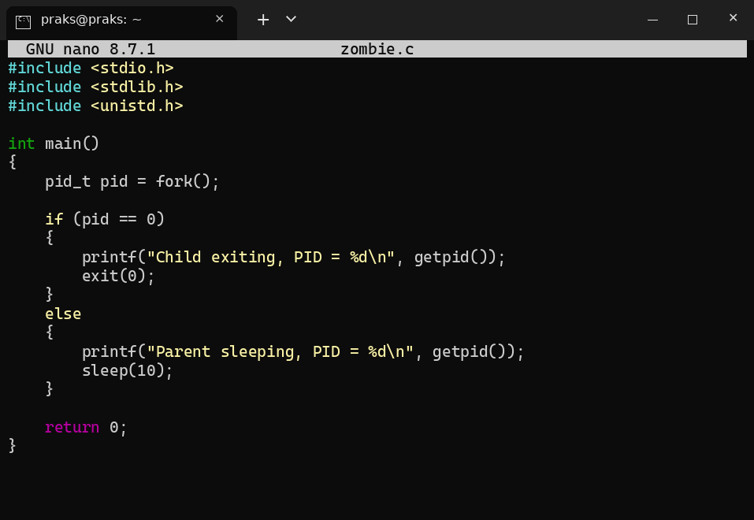
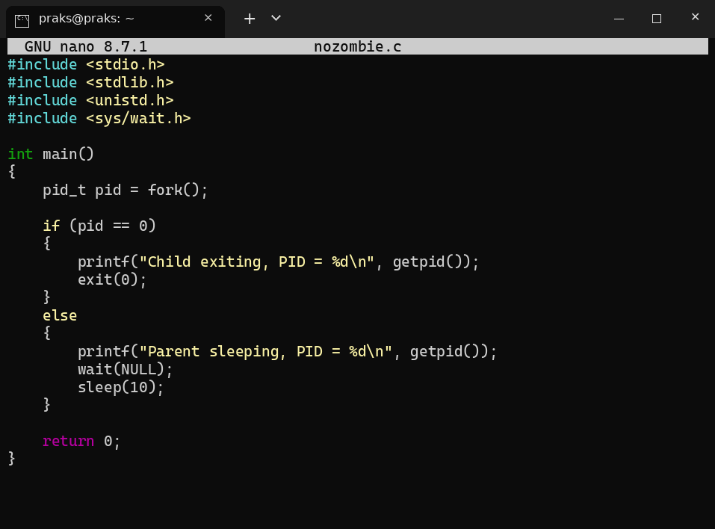
Output:
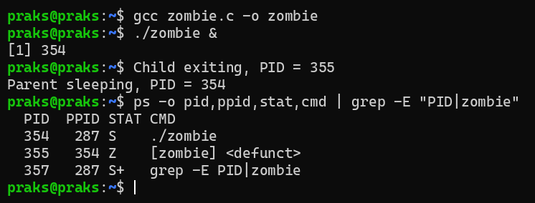
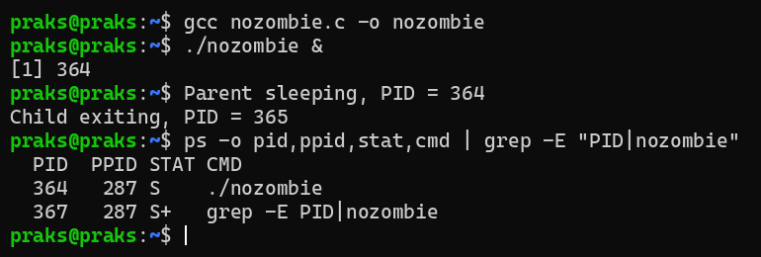
Explanation: In zombie.c the child exits at once but the parent never calls wait(), so the child stays in the process table with state Z (defunct). In nozombie.c the parent calls wait(), which collects the exit status and removes the child from the table, so no defunct process is seen.
5(a). Implement a producer-consumer communication system using anonymous pipes where the parent process generates data and the child process consumes it. Measure the communication efficiency.
Program:
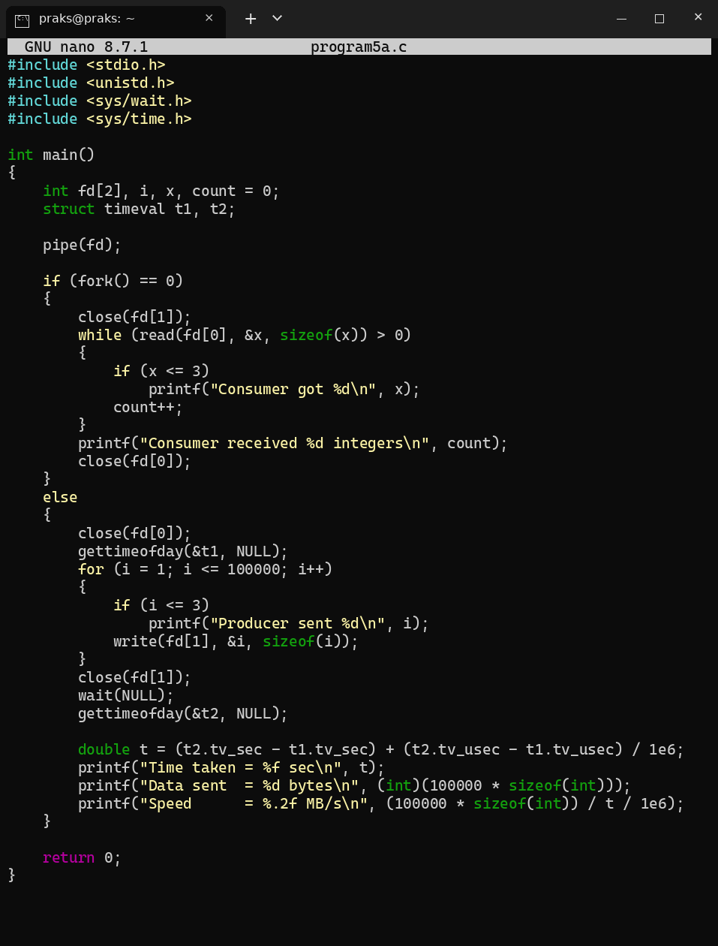
Output:
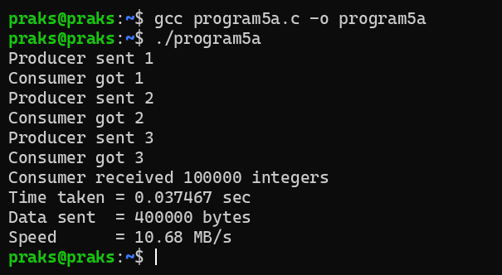
Explanation: The parent (producer) writes 100000 integers into the pipe and the child (consumer) reads them. A pipe blocks the producer when it is full and the consumer when it is empty, so they stay synchronized. 400000 bytes were transferred in 0.037467 sec, which is about 10.68 MB/s.
5(b). Develop a program that executes the equivalent of the shell command: ls -l | grep ".c" using fork(), pipe(), dup2(), and exec() system calls.
Program:
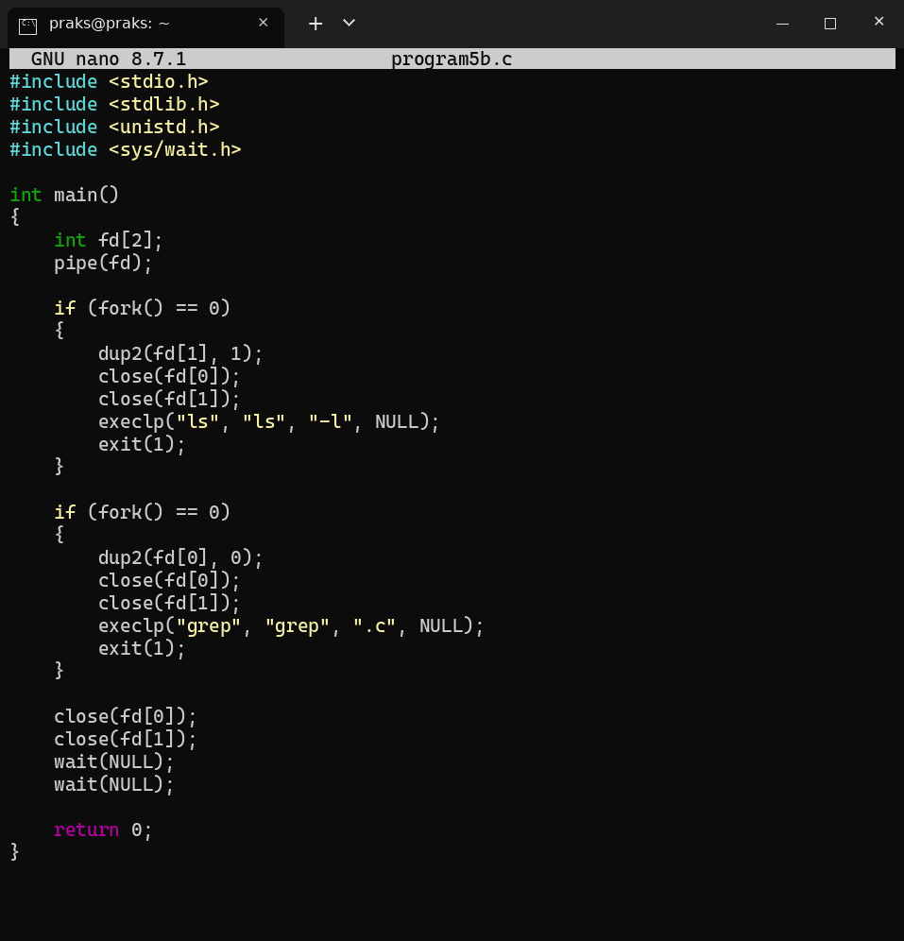
Output:
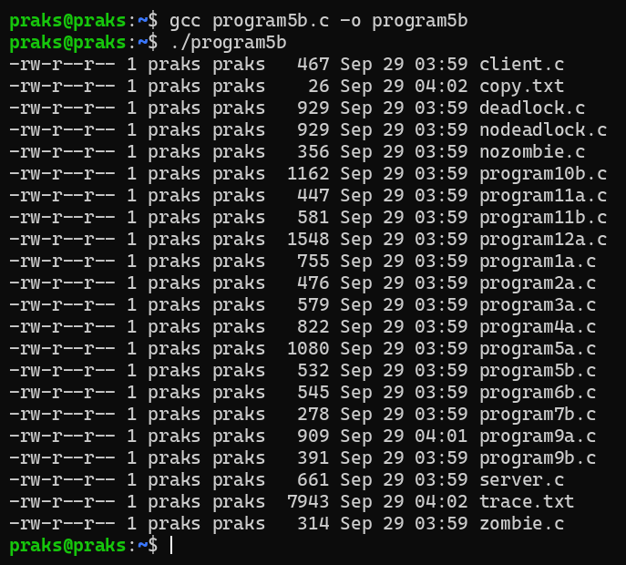
Explanation: pipe() gives two descriptors. The first child does dup2(fd[1], 1) so the output of ls -l goes into the pipe, and the second child does dup2(fd[0], 0) so grep reads from the pipe. exec replaces each child with ls and grep.
6(a). Create a client-server application using Named Pipes (FIFOs). The client sends messages and the server processes and responds to them. Analyze FIFO behavior when multiple clients communicate simultaneously.
Program:
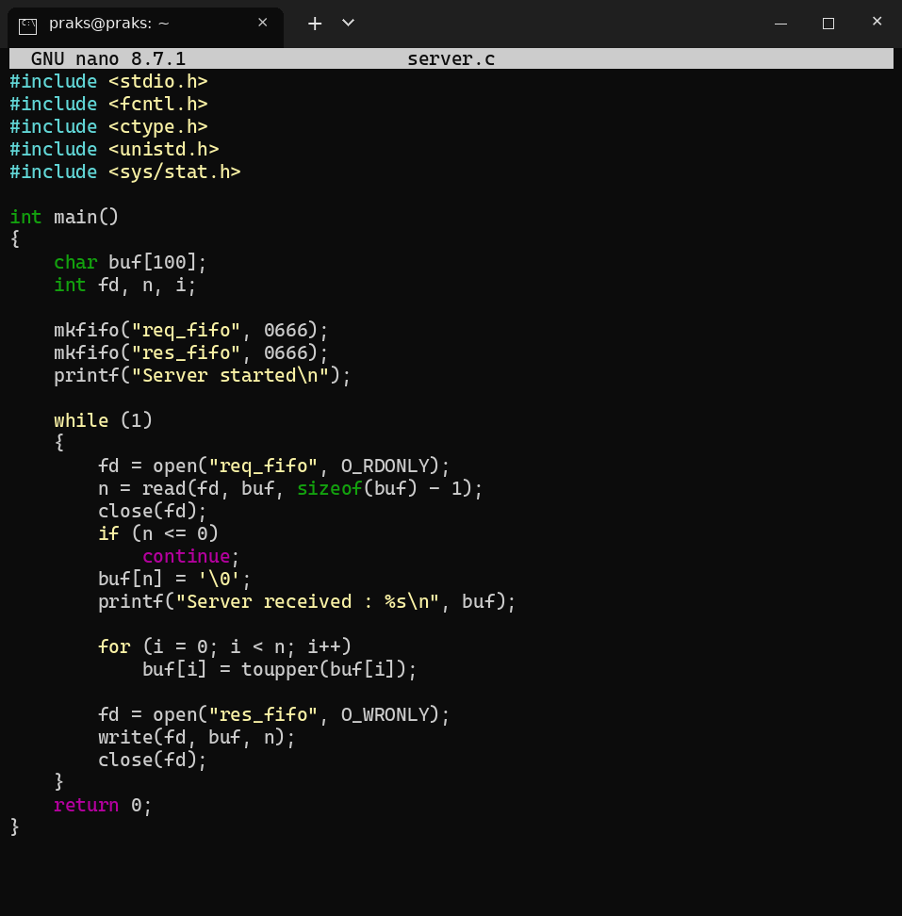
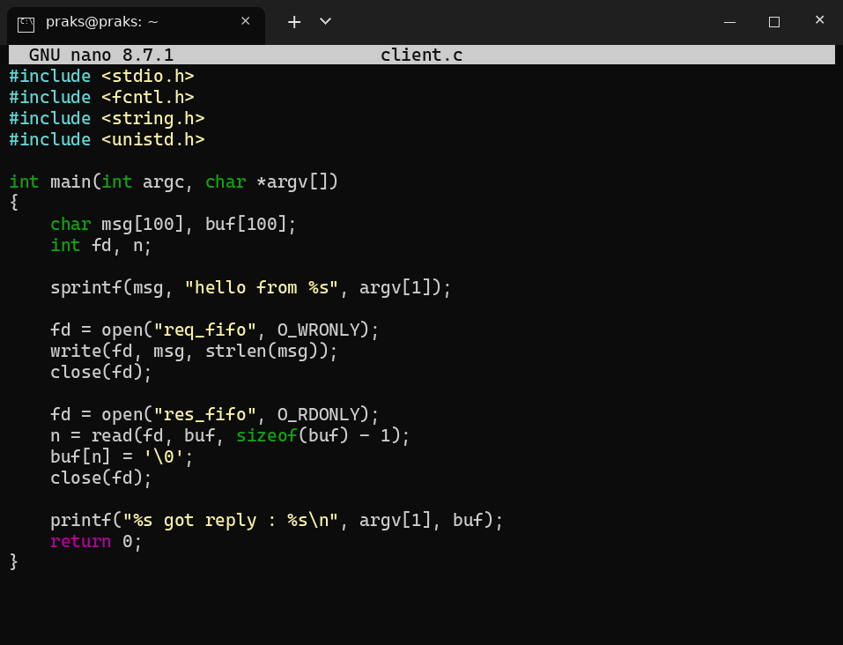
Output:
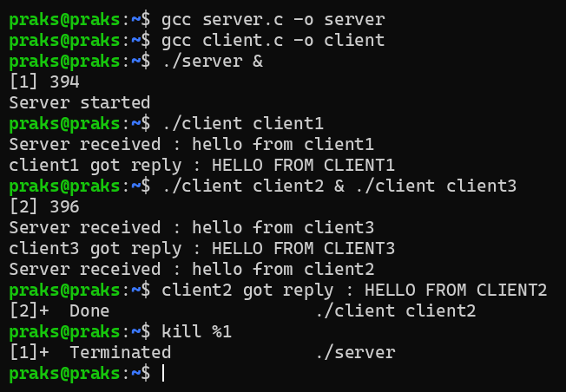
Explanation: The server reads a message from req_fifo, converts it to upper case and writes it to res_fifo. A FIFO is only a byte stream without message boundaries and all clients share the same res_fifo, so when client2 and client3 run together their requests are handled one at a time, and a reply may reach the wrong client or two messages may get merged. To avoid this each client should get its own reply FIFO (for example named with its PID).
6(b). Create a POSIX signal handling program that captures SIGINT, SIGTERM, and SIGUSR1. Demonstrate asynchronous event handling and explain the role of signal handlers.
Program:
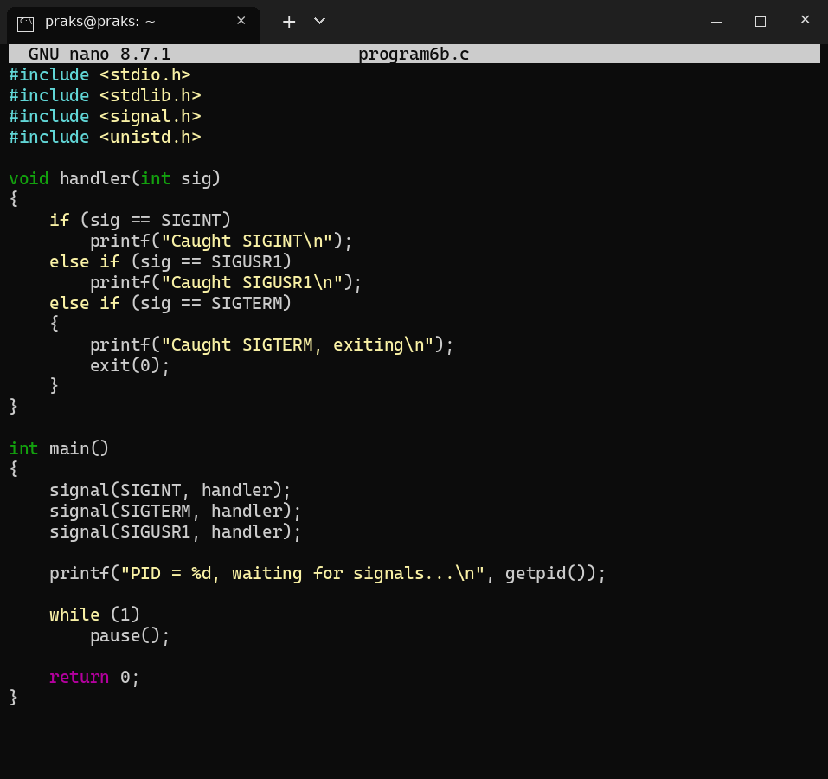
Output:
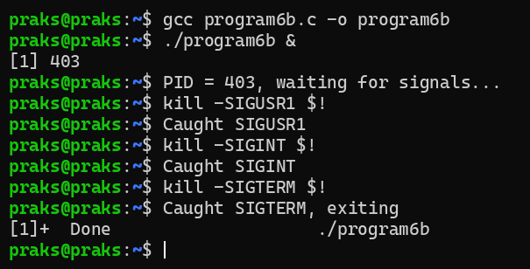
Explanation: A signal is an asynchronous event sent to a process (by kill or the keyboard). signal() registers a handler function. When the signal arrives, the kernel interrupts the normal flow of the program, runs the handler and then the program continues. Here SIGUSR1 and SIGINT were caught and printed, and SIGTERM was caught and the program exited.
7(a). Write a program that prints the addresses of code, global, static, heap, and stack variables. Analyze the Linux process address space layout and explain each memory segment.
Program:
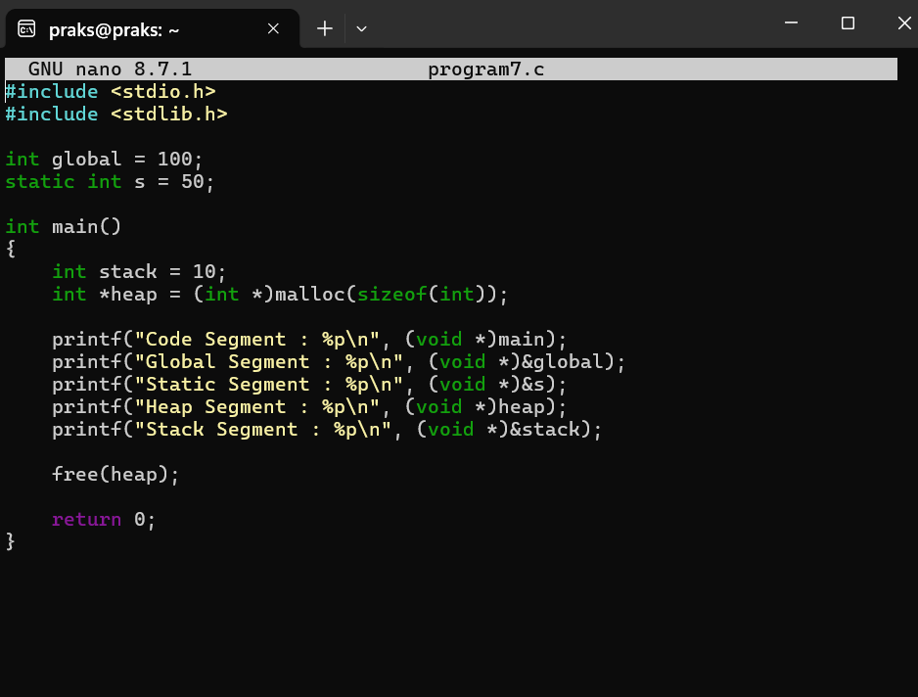
Output:
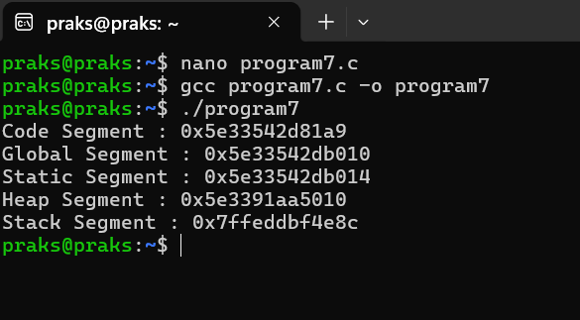
Explanation: Code segment: machine instructions of the program (main). Global and static segment: global and static variables, which live for the whole run (their addresses are next to each other). Heap: memory from malloc(), grows upwards. Stack: local variables and function calls, grows downwards. The output shows code, global and static at nearby low addresses, the heap a little higher, and the stack at a very high address (0x7ffe...).
7(b). Make use of the /proc/<pid>/maps file and memory analysis tools to study the memory organization of a running process. Prepare a report explaining virtual memory mappings.
Program:
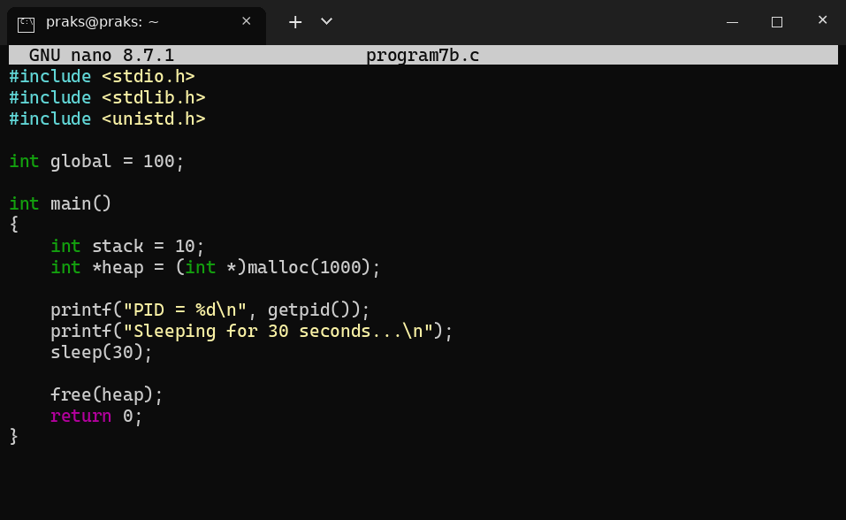
Output:
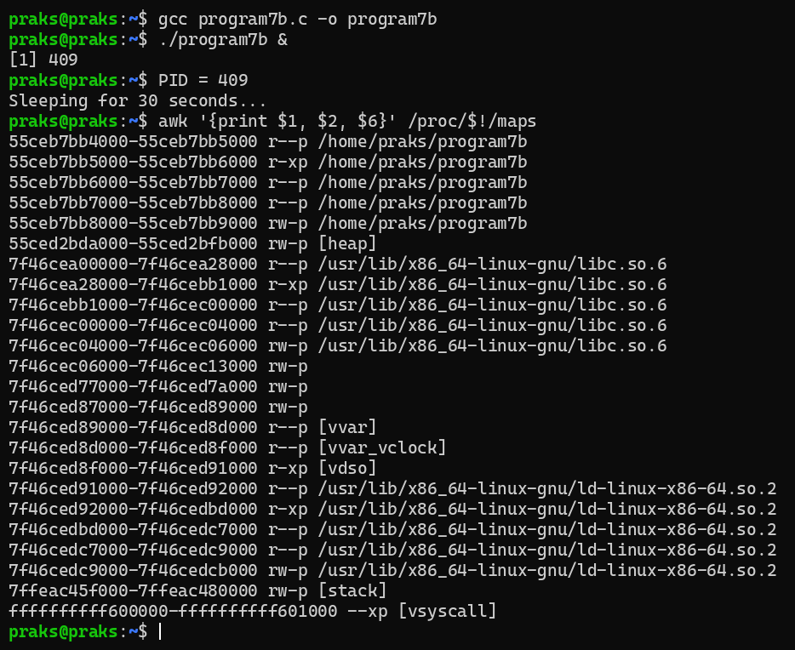
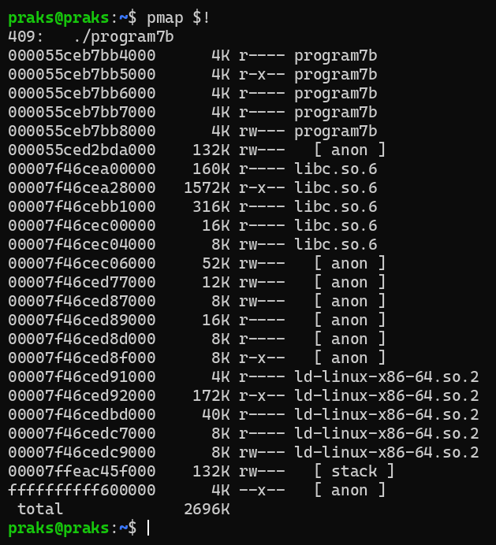
Explanation: maps lists every virtual memory region of the process: program code (r-xp), read-only data, global data (rw-p), [heap], shared libraries (libc.so.6, ld-linux), [vdso] and [stack]. Each line gives the address range, permissions (r, w, x, p = private) and the mapped file. pmap shows the same regions with their sizes. These are virtual addresses: every process has its own address space and the kernel maps it to physical memory pages when needed.
8(a). Develop a program using malloc(), calloc(), realloc(), and free(). Monitor memory allocation behavior and identify memory leaks using Valgrind.
Program:
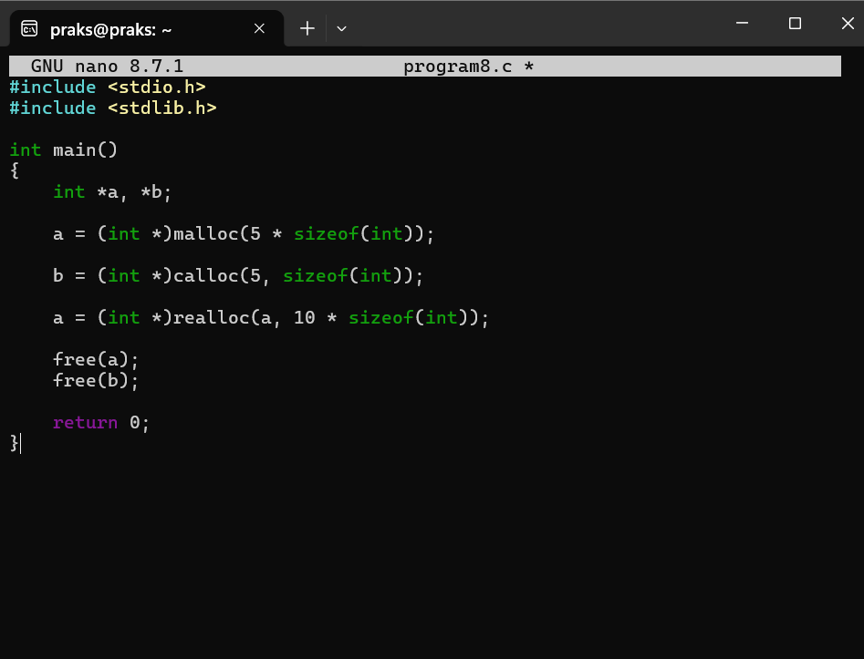
Output:
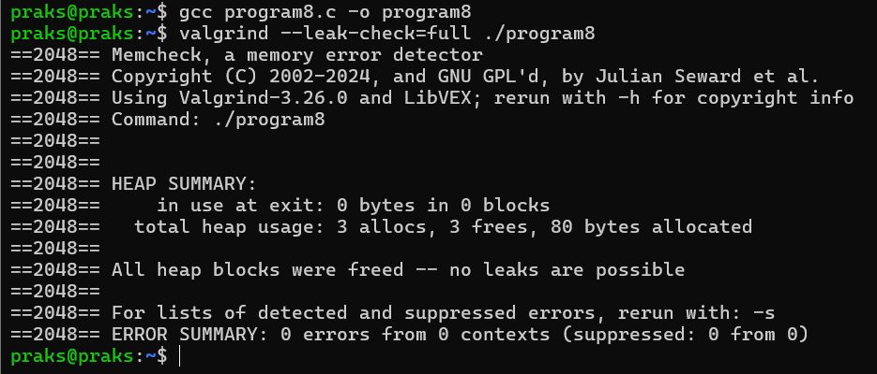
Explanation: malloc() allocates 5 ints (not initialized), calloc() allocates 5 ints set to zero, realloc() resizes the first block to 10 ints, and free() releases both. Valgrind shows 3 allocs and 3 frees, 0 bytes in use at exit, so there is no memory leak.
8(b). Develop a program that demonstrates Copy-on-Write behavior after a fork(). Analyze memory usage before and after modifying data in the child process.
Program:
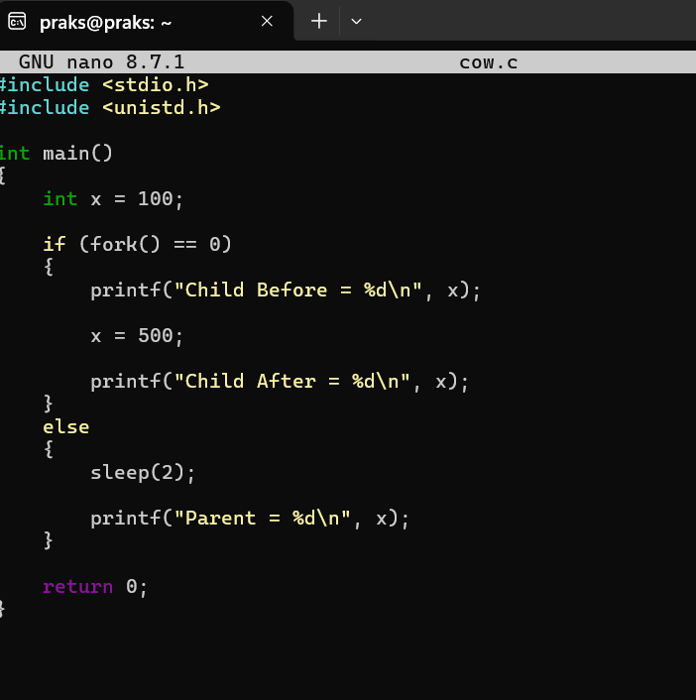
Output:
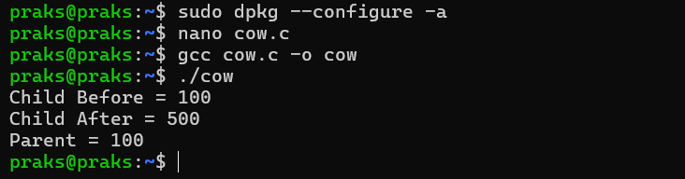
Explanation: After fork() the parent and child share the same physical pages. When the child writes x = 500, the kernel makes a private copy of that page for the child, so the parent still prints 100. No extra memory is used until a write happens.
9(a). Implement a file copy utility using low-level Linux file I/O system calls (open, read, write, lseek, close). Compare its performance with standard library functions (fopen, fread, fwrite).
Program:
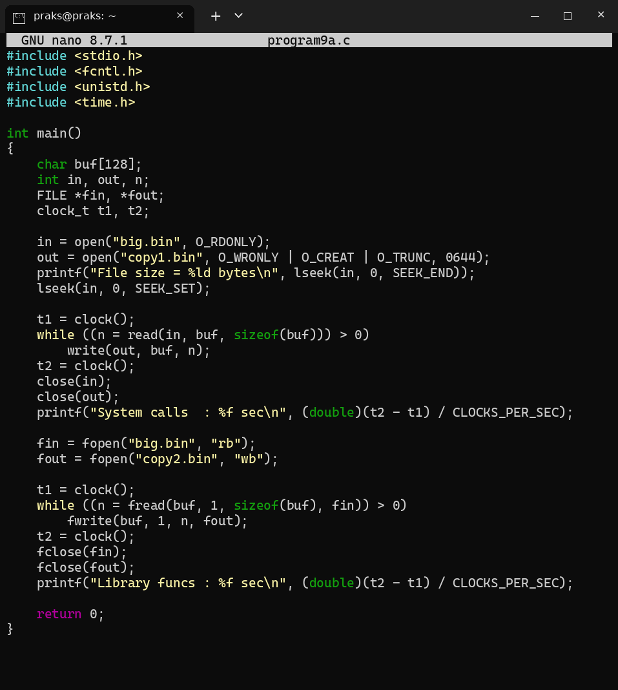
Output:
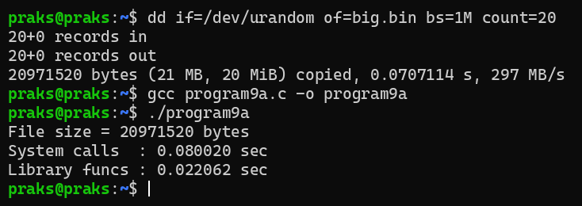
Explanation: read() and write() are direct system calls, so with a small buffer (128 bytes) a large number of system calls is made (0.080020 sec). fread() and fwrite() collect data in an internal buffer, so far fewer system calls are needed and the library version is faster (0.022062 sec). With large buffers both are almost equal.
9(b). Develop a program that redirects standard input and output using file descriptors and dup2(). Demonstrate how shells implement I/O redirection.
Program:
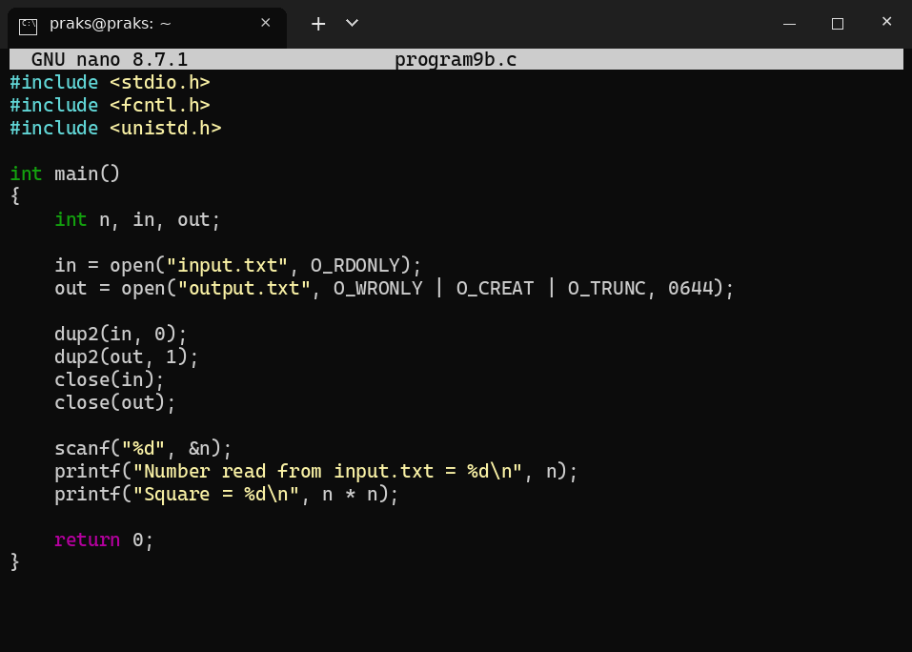
Output:
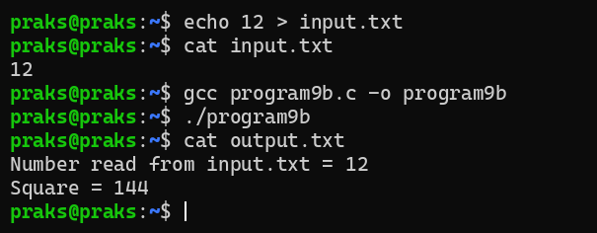
Explanation: dup2(in, 0) makes descriptor 0 (stdin) refer to input.txt and dup2(out, 1) makes descriptor 1 (stdout) refer to output.txt. So scanf() reads from the file and printf() writes to the file, and nothing is printed on the screen. A shell does the same for ./program < input.txt > output.txt: it forks, calls dup2() in the child and then runs the program with exec.
10(a). Investigate inode structures using commands such as ls -i, stat, and find. Create hard links and symbolic links and explain their impact on inode allocation.
Commands and Output:
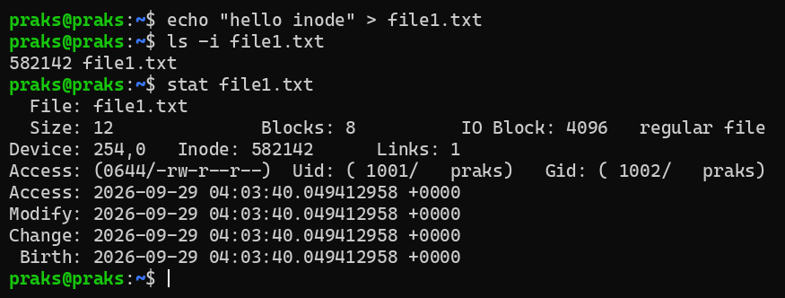
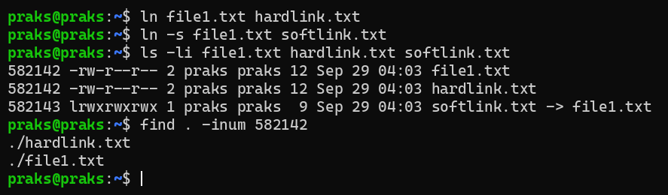
Explanation: A file name is only a directory entry that points to an inode; the inode stores the size, owner, permissions, timestamps and data block pointers. A hard link (hardlink.txt) is another name for the same inode: the inode number is the same, the link count becomes 2 and no new inode is allocated. A symbolic link is a separate file with its own inode that stores the path of the target, so it uses a new inode.
10(b). Design a program using mmap() to perform file reading and writing. Compare memory-mapped I/O with traditional read/write operations in terms of efficiency and implementation complexity.
Program:
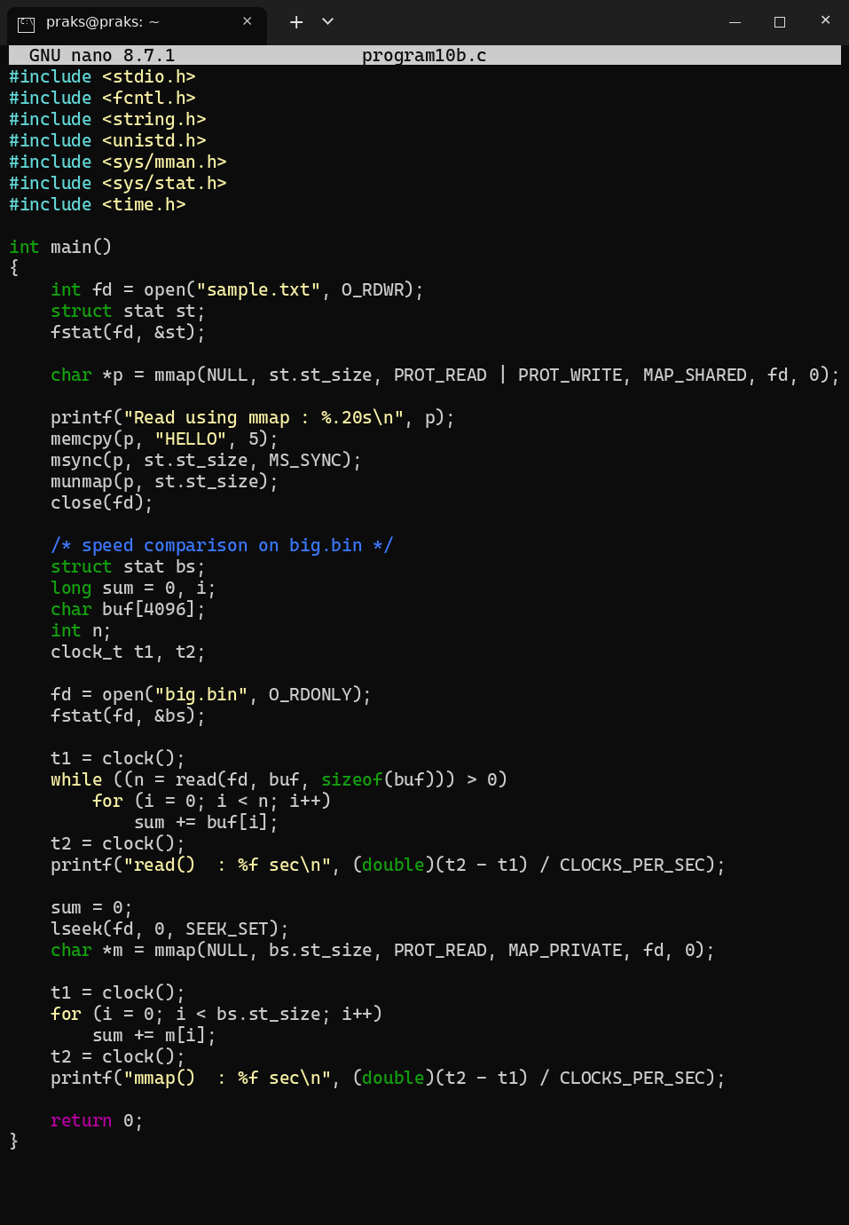
Output:
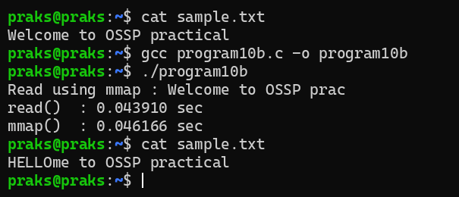
Explanation: mmap() maps the file into the address space, so the contents are used like a normal array and are changed with memcpy() (the first 5 letters of sample.txt became HELLO) without read() or write() calls. For the 20 MB file read() took 0.043910 sec and mmap() took 0.046166 sec, so speed is similar here; mmap avoids the extra copy and repeated system calls and is best for large files and random access, but it is harder to code (msync, munmap, fixed file size, page faults).
11(a). Develop a multithreaded counter application using POSIX threads (pthread_create, pthread_join). Demonstrate race conditions by allowing multiple threads to update a shared variable concurrently.
Program:
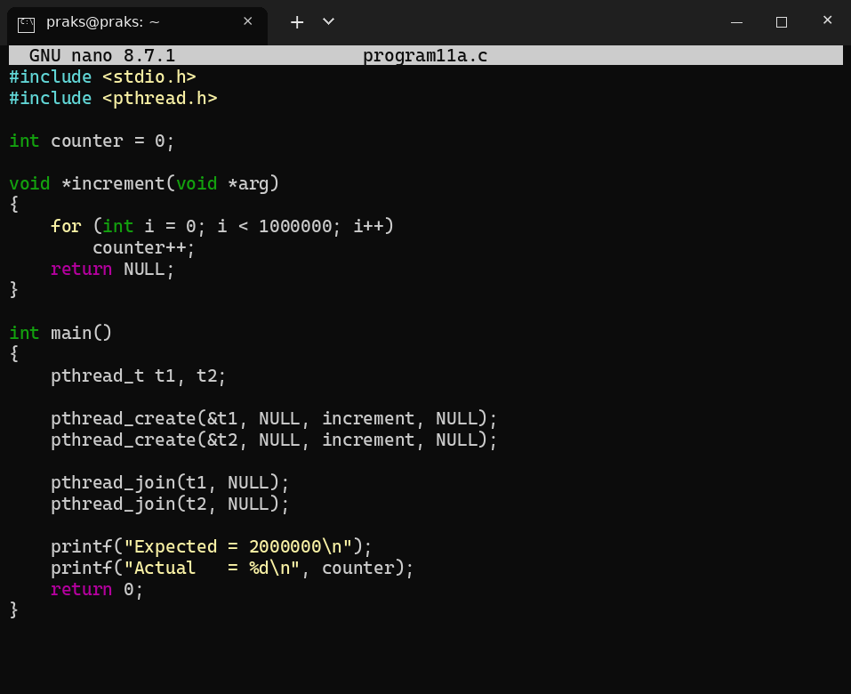
Output:
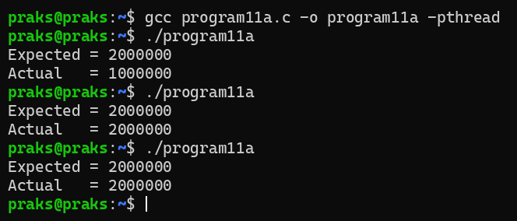
Explanation: Both threads run counter++ on the same variable. counter++ is really load, add and store, so if a thread is switched out in between, an update is lost. The actual value can therefore be less than the expected 2000000 and may change from run to run. This is a race condition.
11(b). Modify the previous program using mutex locks (pthread_mutex_lock, pthread_mutex_unlock) and compare the outputs with the race-condition version. Analyze the impact of synchronization.
Program:
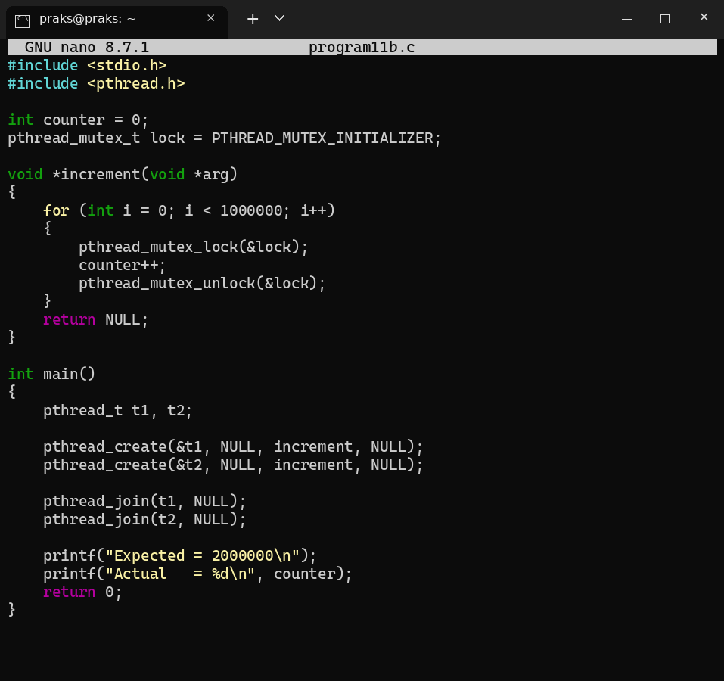
Output:
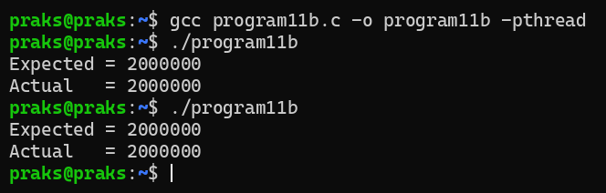
Explanation: The mutex allows only one thread at a time to update counter, so no update is lost and the result is always exactly 2000000. Synchronization makes the program correct, but it is slower because threads have to wait for the lock.
12(a). Implement the Producer-Consumer problem using counting semaphores and POSIX threads. Evaluate synchronization correctness and system throughput under different buffer sizes.
Program:
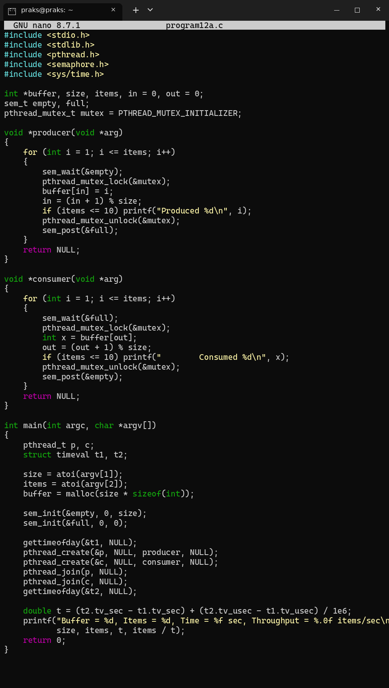
Output:
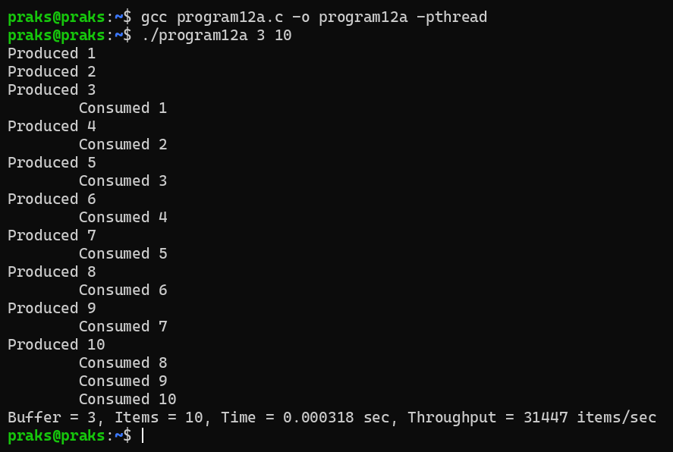
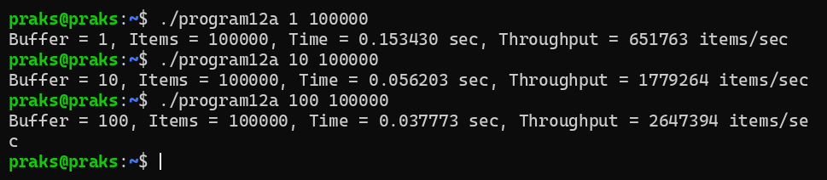
Explanation: empty counts free slots (starts at the buffer size), full counts filled slots (starts at 0) and the mutex protects the buffer. The producer waits when the buffer is full and the consumer waits when it is empty, so every item is consumed exactly once and in order. Throughput increases with the buffer size: 651,763 items/sec for buffer 1, 1,779,264 for buffer 10 and 2,647,394 for buffer 100, because the threads block and switch less often.
12(b). Design a deadlock scenario involving multiple threads competing for shared resources. Demonstrate deadlock occurrence, identify the four necessary conditions for deadlock, and implement a deadlock prevention strategy using resource ordering.
Program:
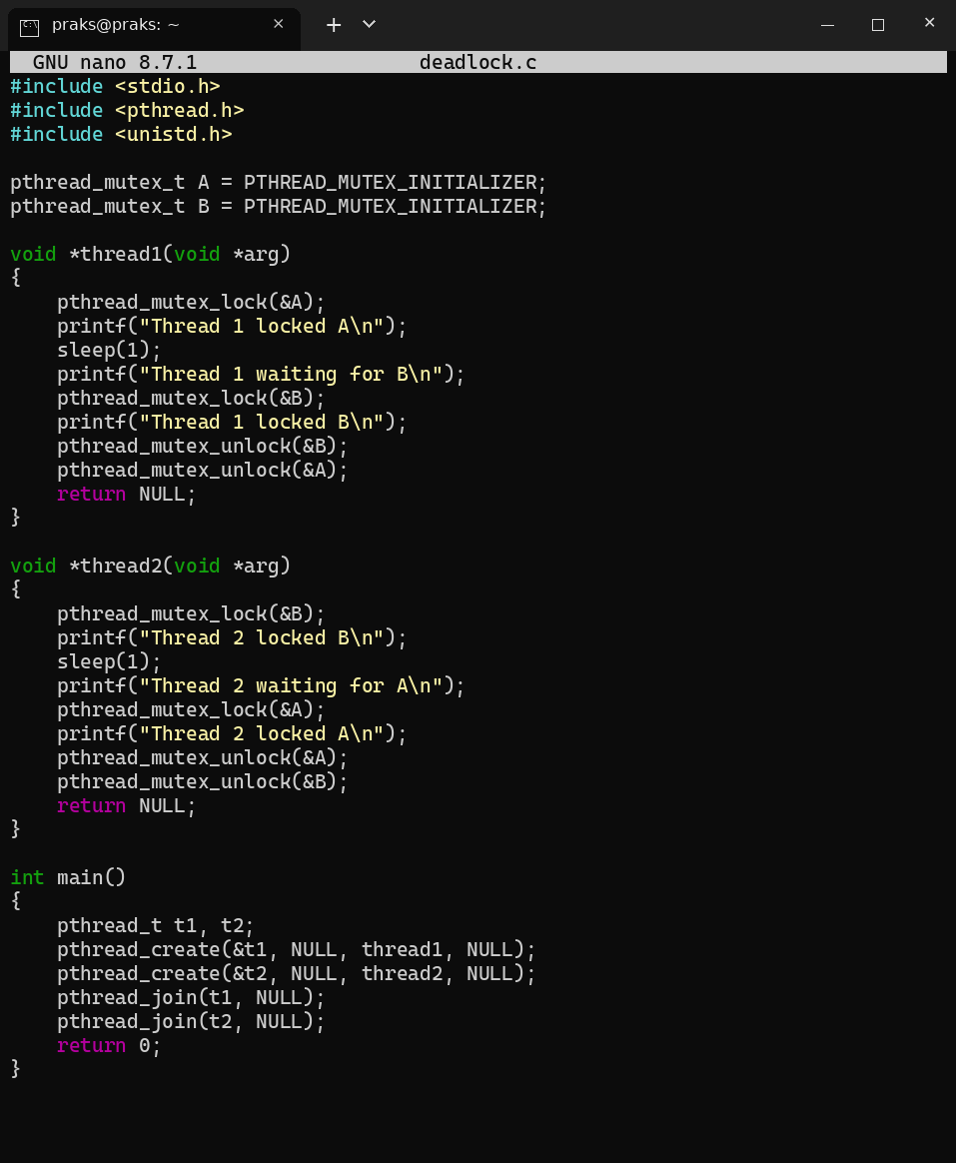
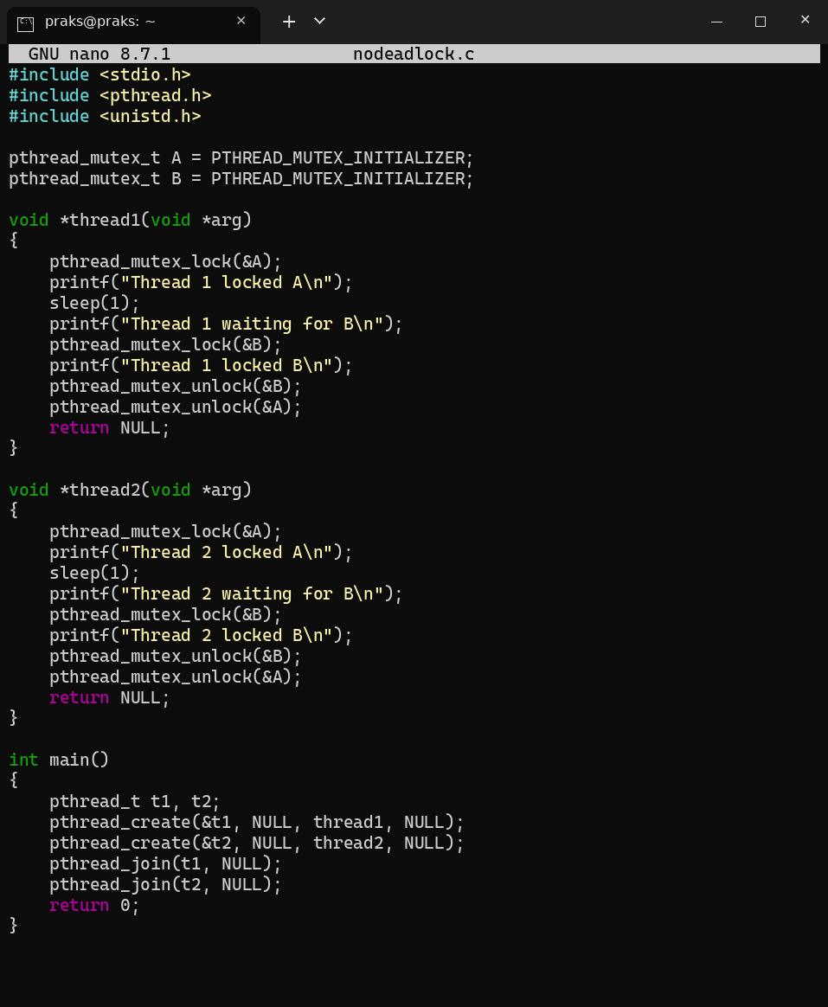
Output:
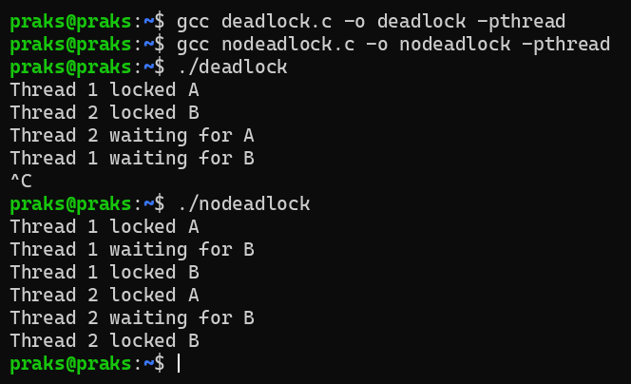
Explanation: In deadlock.c Thread 1 holds A and waits for B while Thread 2 holds B and waits for A, so both wait forever (stopped with Ctrl+C). Four necessary conditions: (1) mutual exclusion - a mutex can be held by only one thread, (2) hold and wait - each thread holds one lock while waiting for the other, (3) no preemption - a lock cannot be taken away, (4) circular wait - Thread 1 waits for Thread 2 and Thread 2 waits for Thread 1. Prevention: in nodeadlock.c both threads lock in the same order (A then B), which removes circular wait, so both threads finish.

